Assignment for **Oracle E- Business Suite General Ledger**

Date:15th Nov-2024

[Provide screenshots of each step (which performed in a live environment).  
As evidence all the activity screens shot needs to be attached]

1.Create Your Own user ID from System Administrator Responsibility.

System Administrator> Security > User > Define

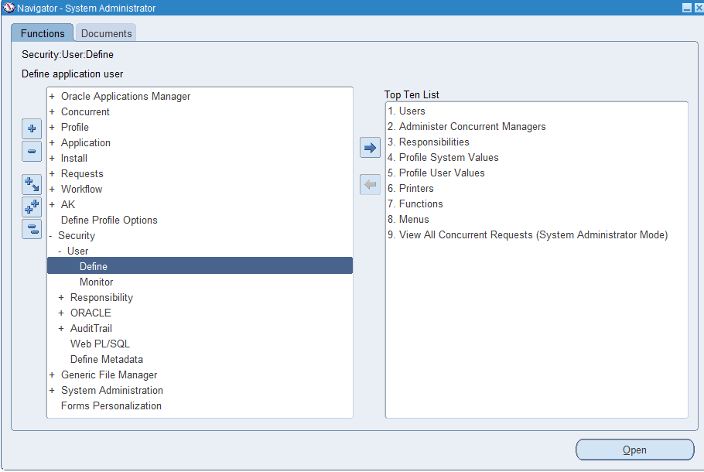  
 Assign the following responsibilities to your Oracle User ID

* **Vision Operation General Ledger.**
* **Vision Operation Inventory**.
* **Vision Operation Procurement**

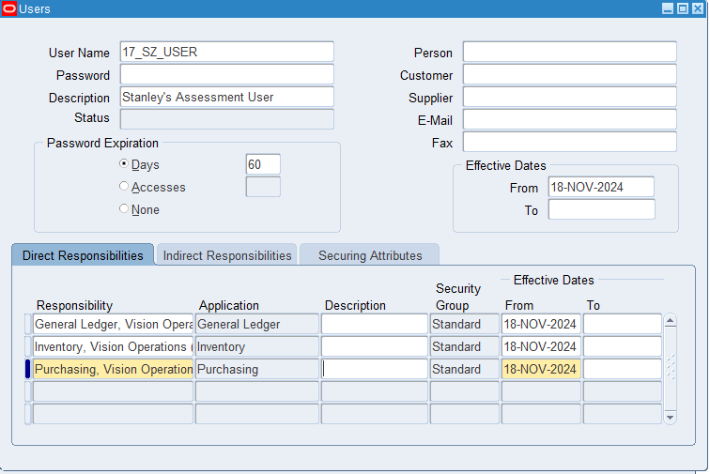

2. For your user ID password expiration day should be 60 days

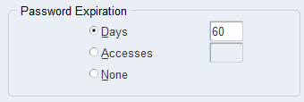

3. In **Vision Operation General Ledger** responsibility.

Form Accounting Setup Manager> Find the **Vision Operation [Primary Ledger]**

General Ledger, Vision Operations (USA) > Setup > Financials > Accounting Setup Manager > Accounting Setups

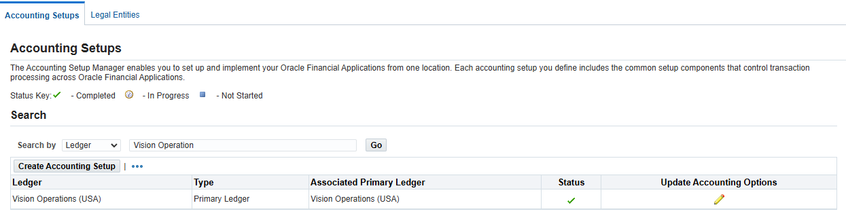

In this Ledger finds the **4C** Component, mentions the 4C name & take the screen shot as Evidence.

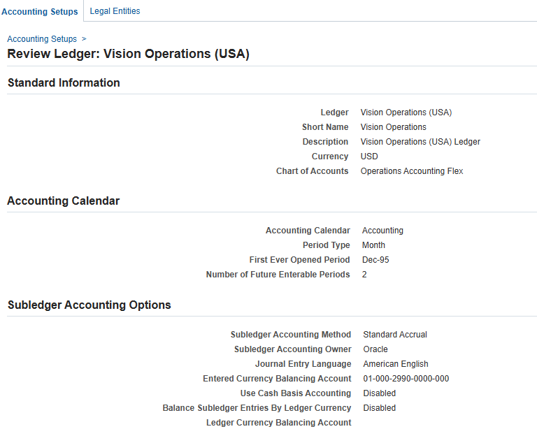

Chart of Accounts: Operations Accounting Flex

Currency: USD

Accounting Calendar: Accounting, Month, Dec-95

Accounting Method: Standard Accrual

1. Find the Respective Calendar **Vision Operation [Primary Ledger].**

**-** Setup > Financials> Calendars> Accounting>Ctrl F11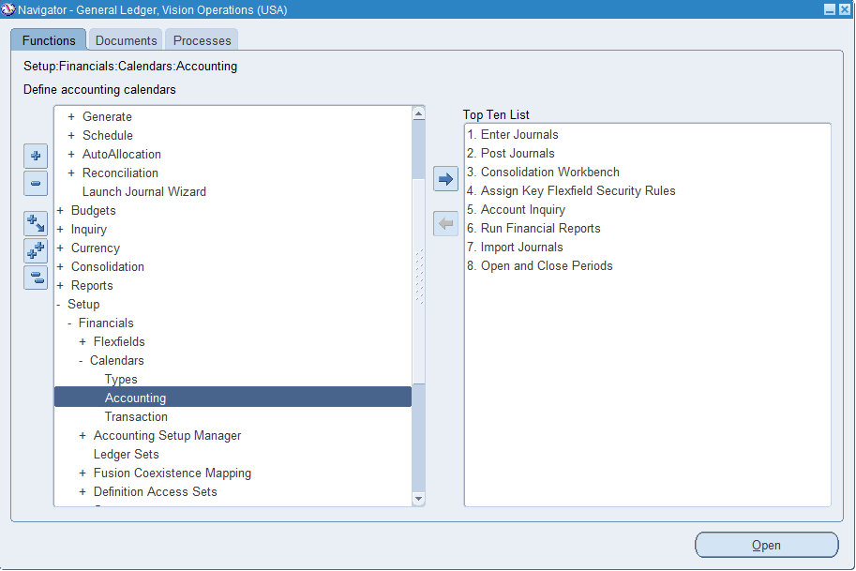

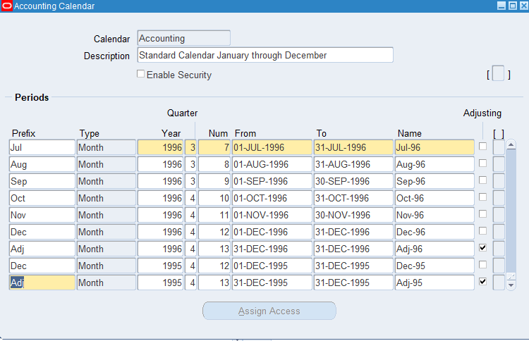

4.Find all the **Account Code Combinations.**

* Responsibility: General Ledger, Vision Operations (USA) > Setup > Accounts > Combinations

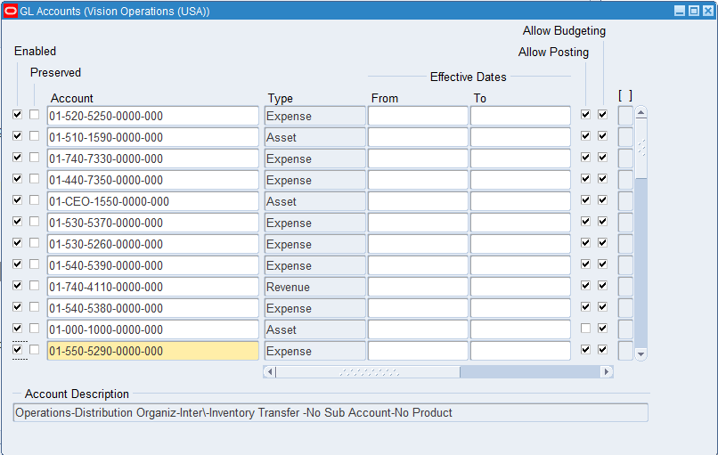

5.Find all the Journals [**SOURCE: Payables].**

* Responsibility: GL, Vision Operations(USA) > Journals > Enter
* 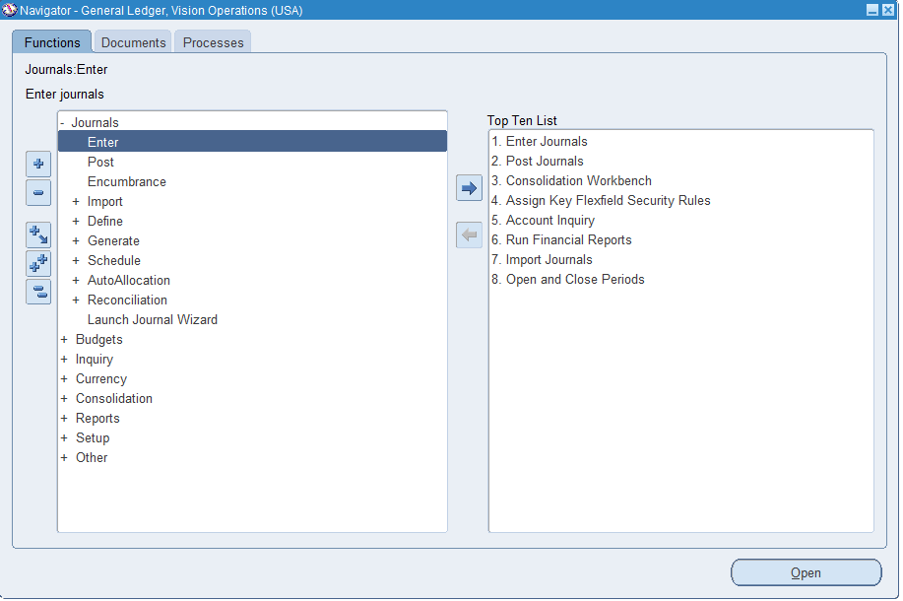

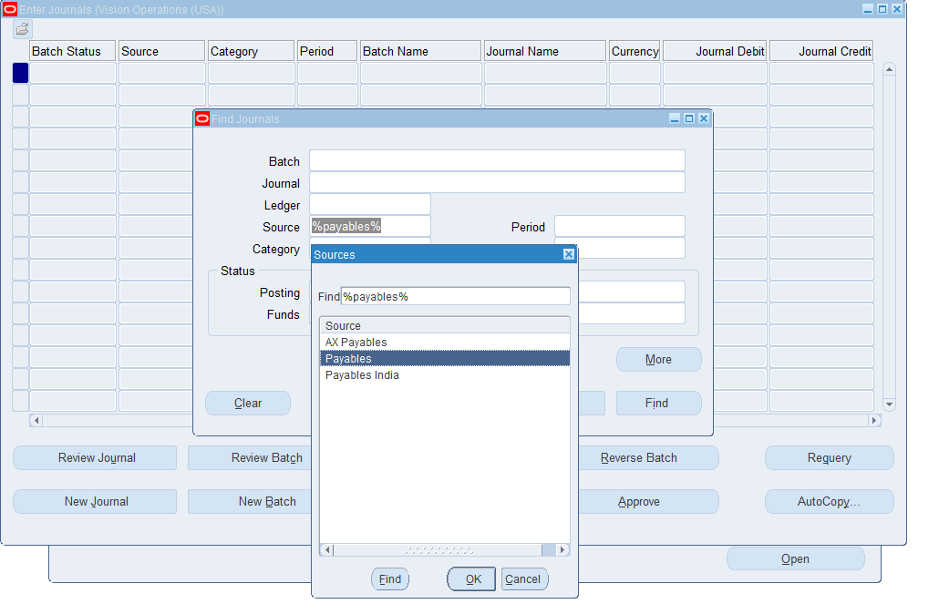

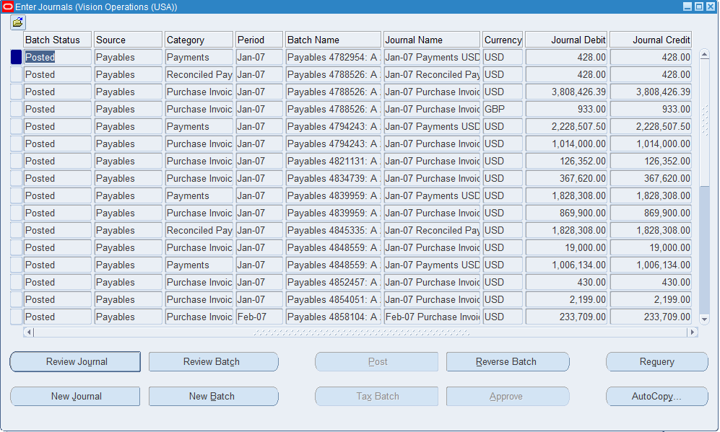

6. In Journal Header from record History find the respective **Data base Table name.**

* Help > Record History

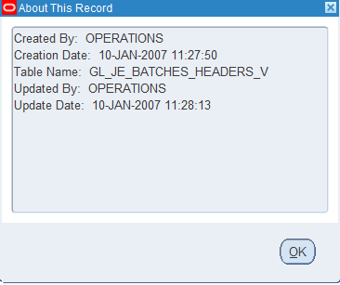

7. Find the one Manual [Source] & one Payable [Source].

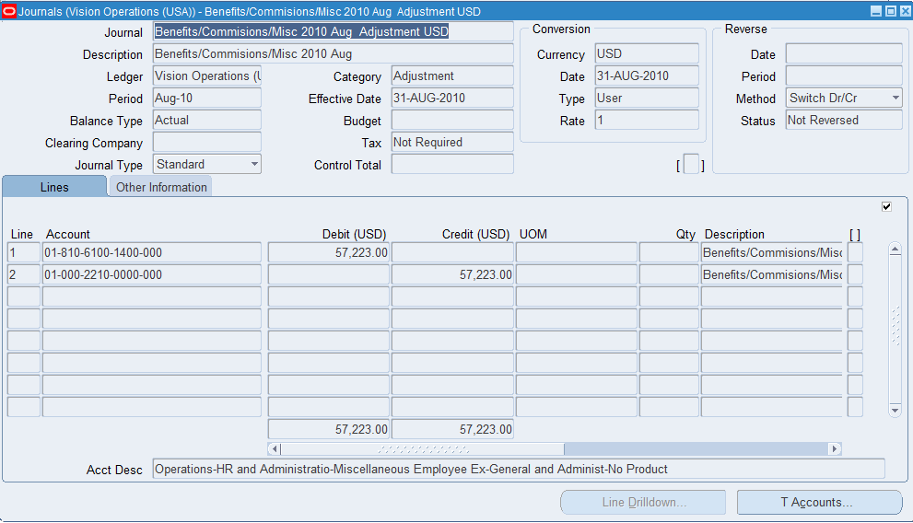

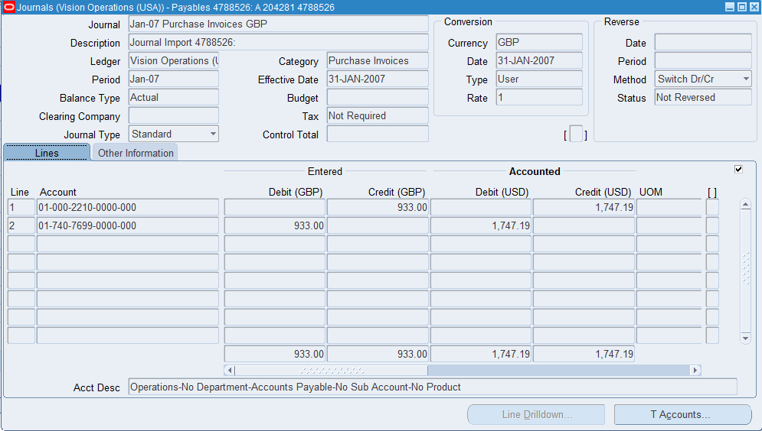

8.How can you review posted journal entries in Oracle GL? Steps & screen shots

* Responsibility: General Ledger, Vision Operations(USA) > Inquiry > Journal

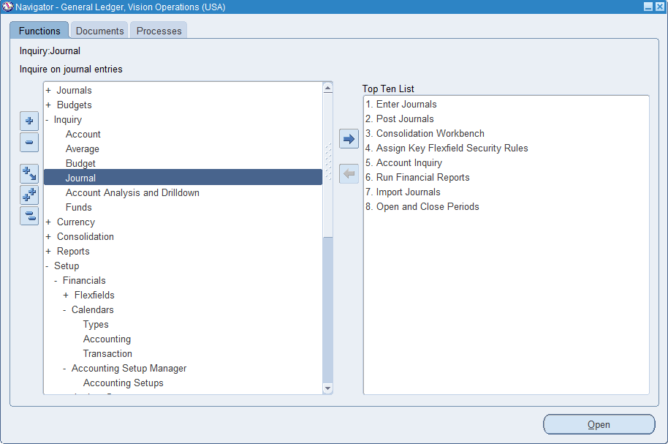

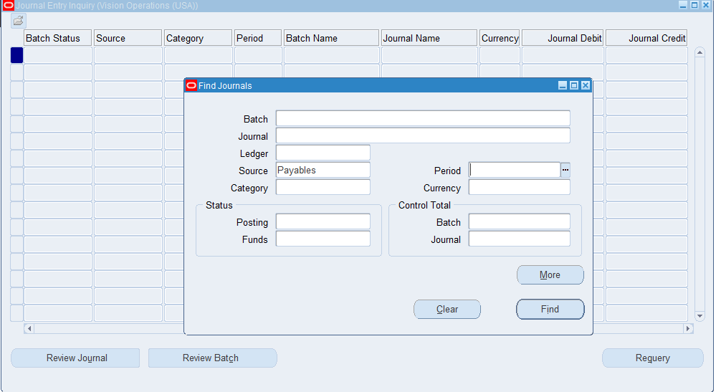

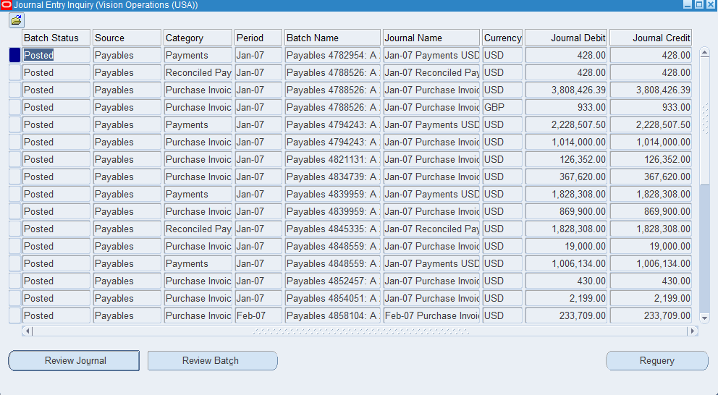

9. Find the **Chart of Accounts [COA]** Structure in General Ledger.

Setup>Financials>Flexfields>Key>Segments

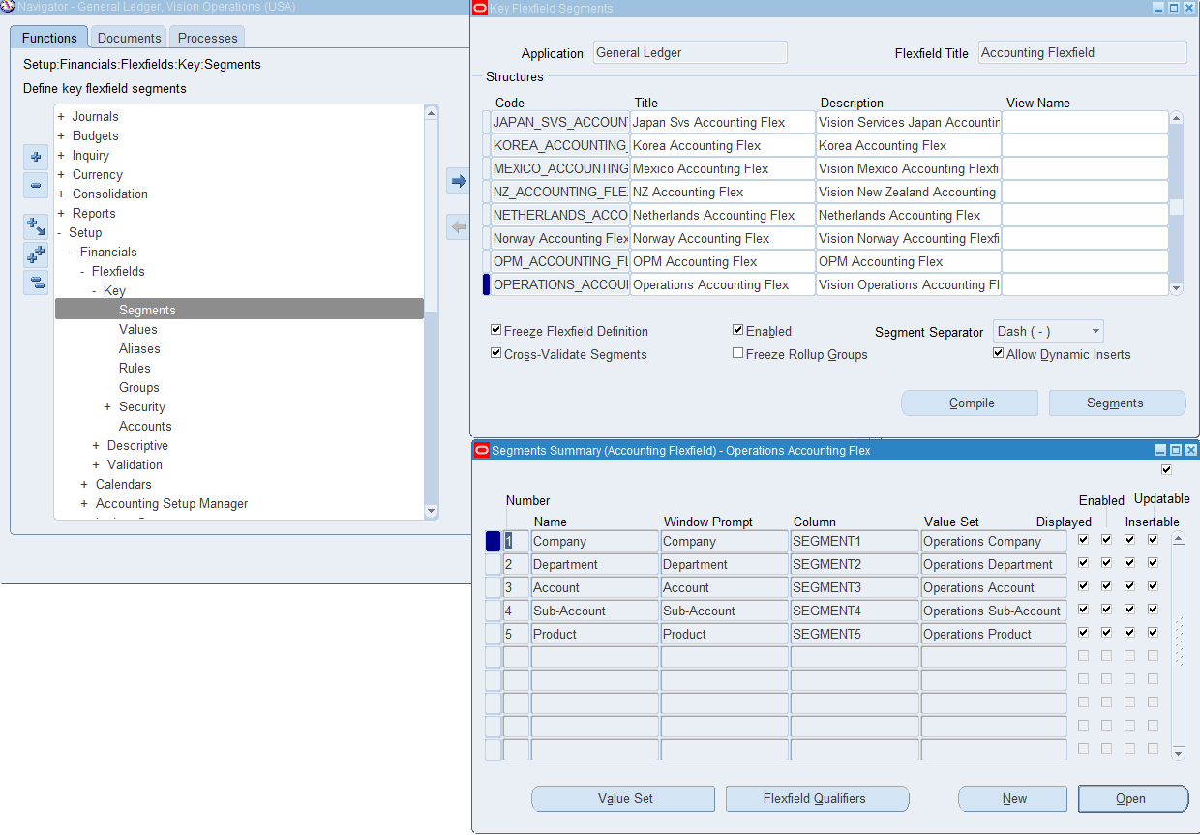

10.How are you going to run one **Concurrent Request** from General Ledger (Navigation).

* View> requests>Submit a new request

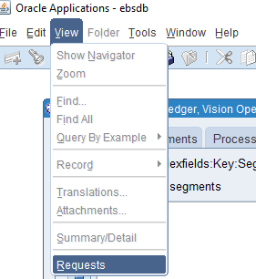

* 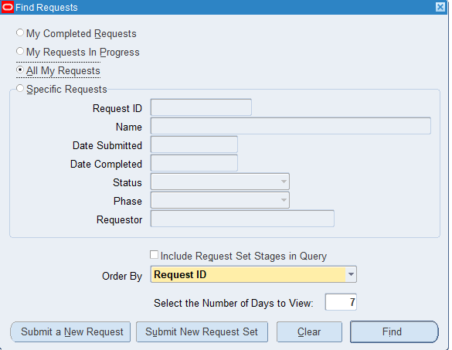
* 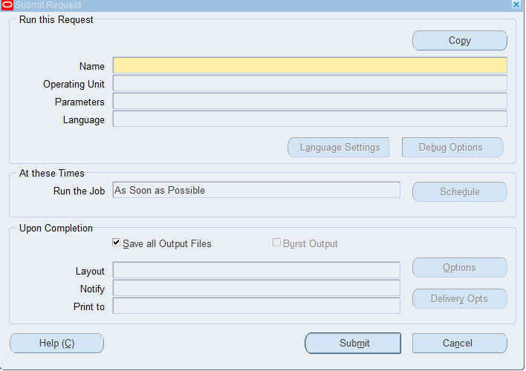
* 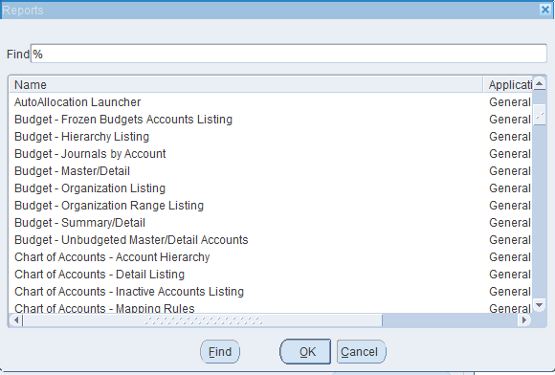

11. In One Ledger Set what are all components common in all the Ledger?

* Chart of Accounts, Accounting Calendar, Currency, Subledger Accounting Method, Consolidation Method, Ledger Class

12. Find how many types of accounts in Oracle GL [Account Code Combination]?

* Accounts>Combinations
* Liability: Obligations
* Asset: Resources owned by the organization
* Revenue: Income
* Expense: Costs incurred
* Equity: Ownership Interest

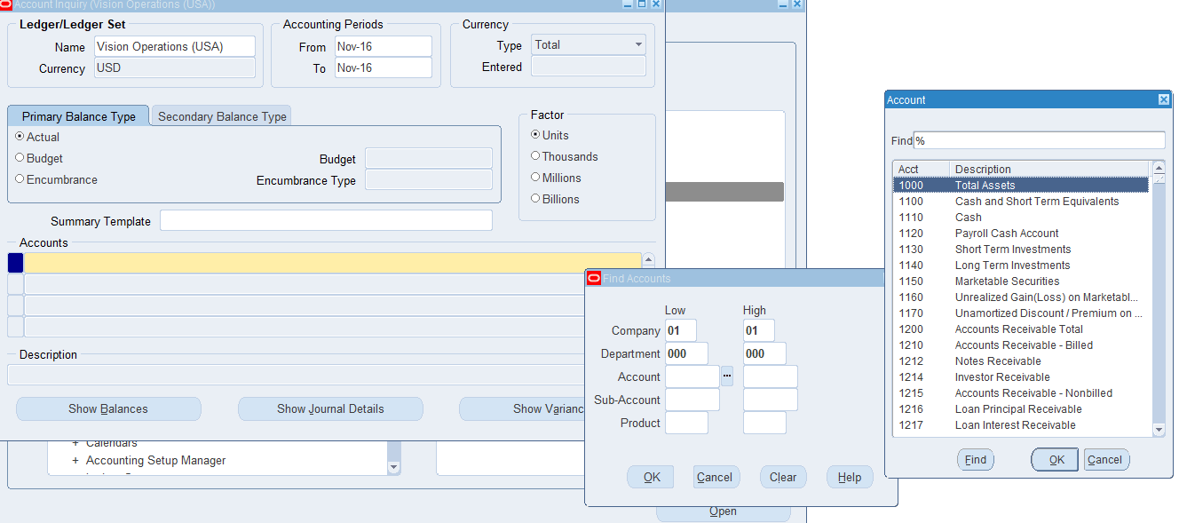

13. Check & show the Structure of Chart of Account segment structure.

* Setup>Financials>Flexfields>Keys>Segments>Ctrl F11> Segments

